ASSIGNMENT-1

SUBTASK-B

CONTRIBUTIONS BY-

Abhishek Amrendra Kumar (2022CS11598)

Toshi Pahadia(2022CS11127)

DESIGN DECISIONS AND TRADE-OFFS:-

1. Imported Libraries: We imported a number of libraries, notably yfinance, pandas and plotly for plotting graphs.

2. File Handling:

- The code reads data from CSV and text files to obtain company symbols and names. This data is used for various purposes like fetching stock information and filtering.

3. Refreshing Data:

- There's a function `refresh_data()` to fetch and update stock-related information. This function fetches data for all symbols in the list and updates a global variable `values` with the fetched information.

- Trade-off: This approach might lead to longer response times or even timeouts if there are a large number of symbols to fetch and update.

4. Data Visualization:

- The application generates candlestick plots using Plotly library to visualize stock data based on the selected range (e.g., 1 day, 1 week, 1 month).

5. Filtering and Searching:

- The application allows users to filter companies based on market capitalization, PE ratio, and closing price. It also supports searching for companies based on a query string.

- Trade-off: Implementing efficient filtering and searching algorithms ensures better user experience, especially when dealing with large datasets. However, it might require optimization for performance.

SCREENSHOTS OF DIFFERENT END-POINTS:-

LOGIN PAGE

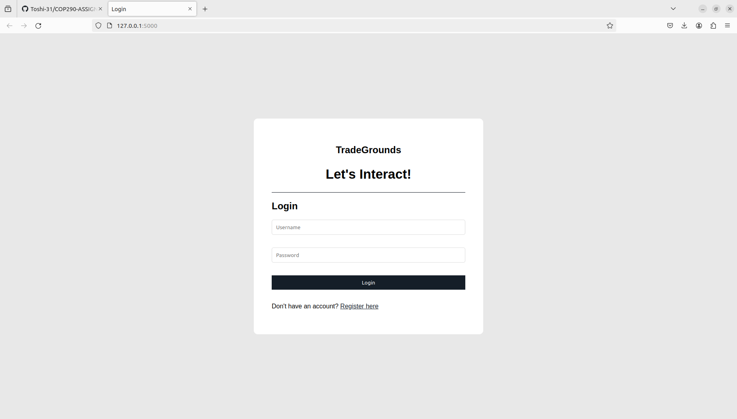

REGISTER PAGE

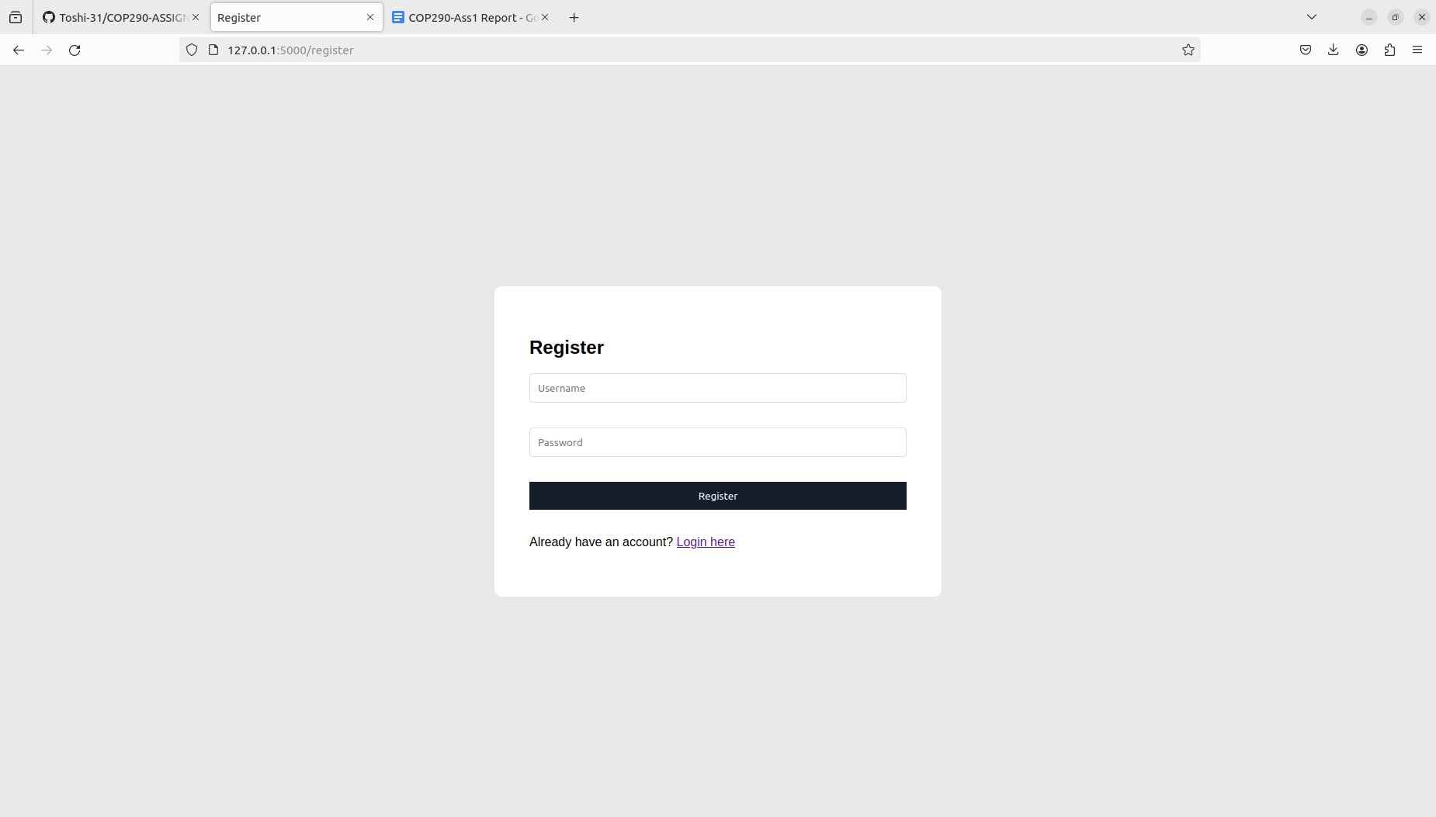

DASHBOARD

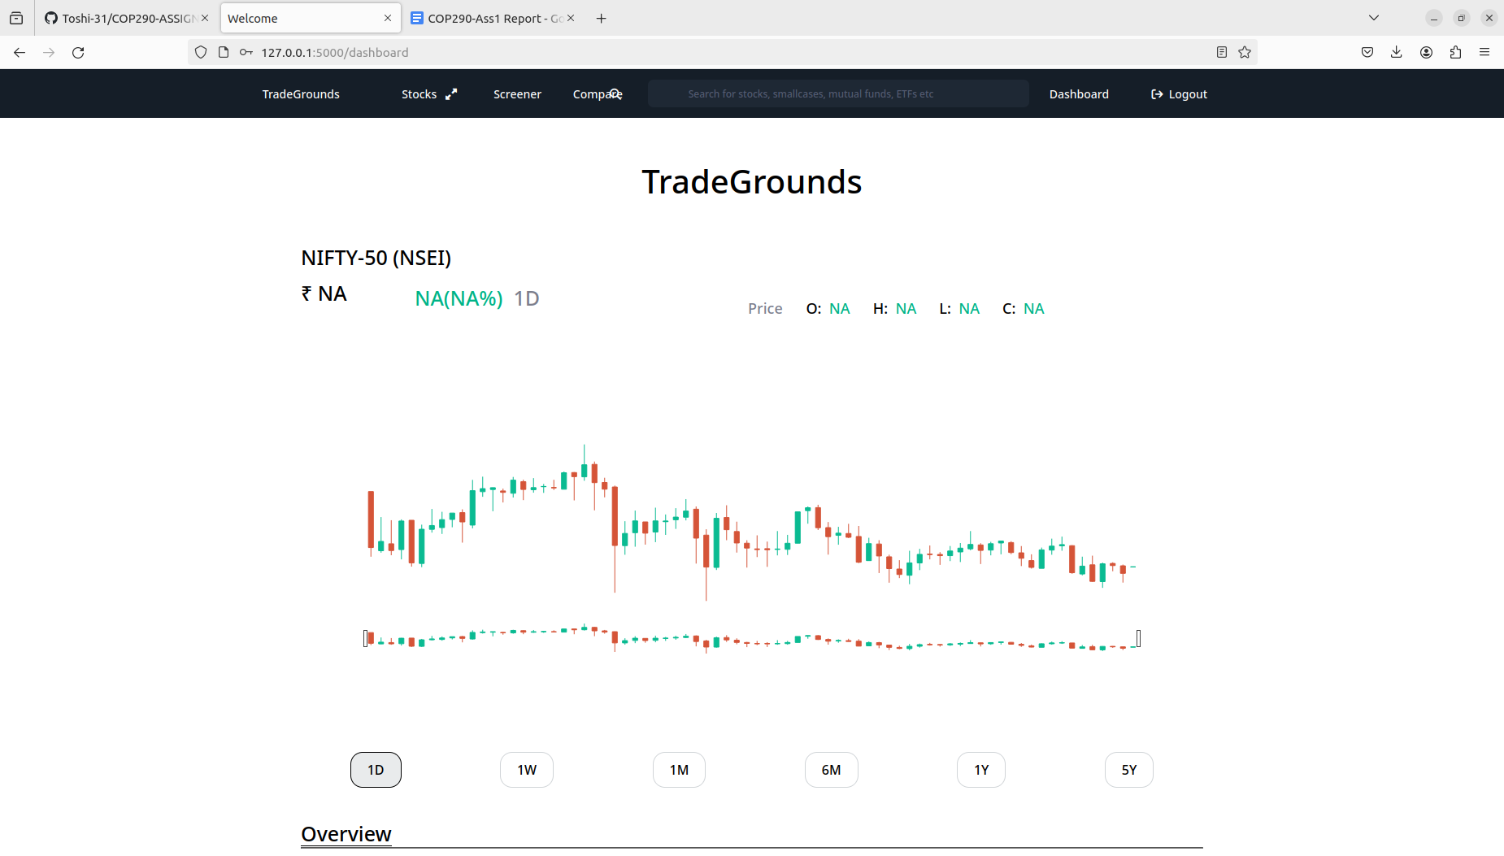

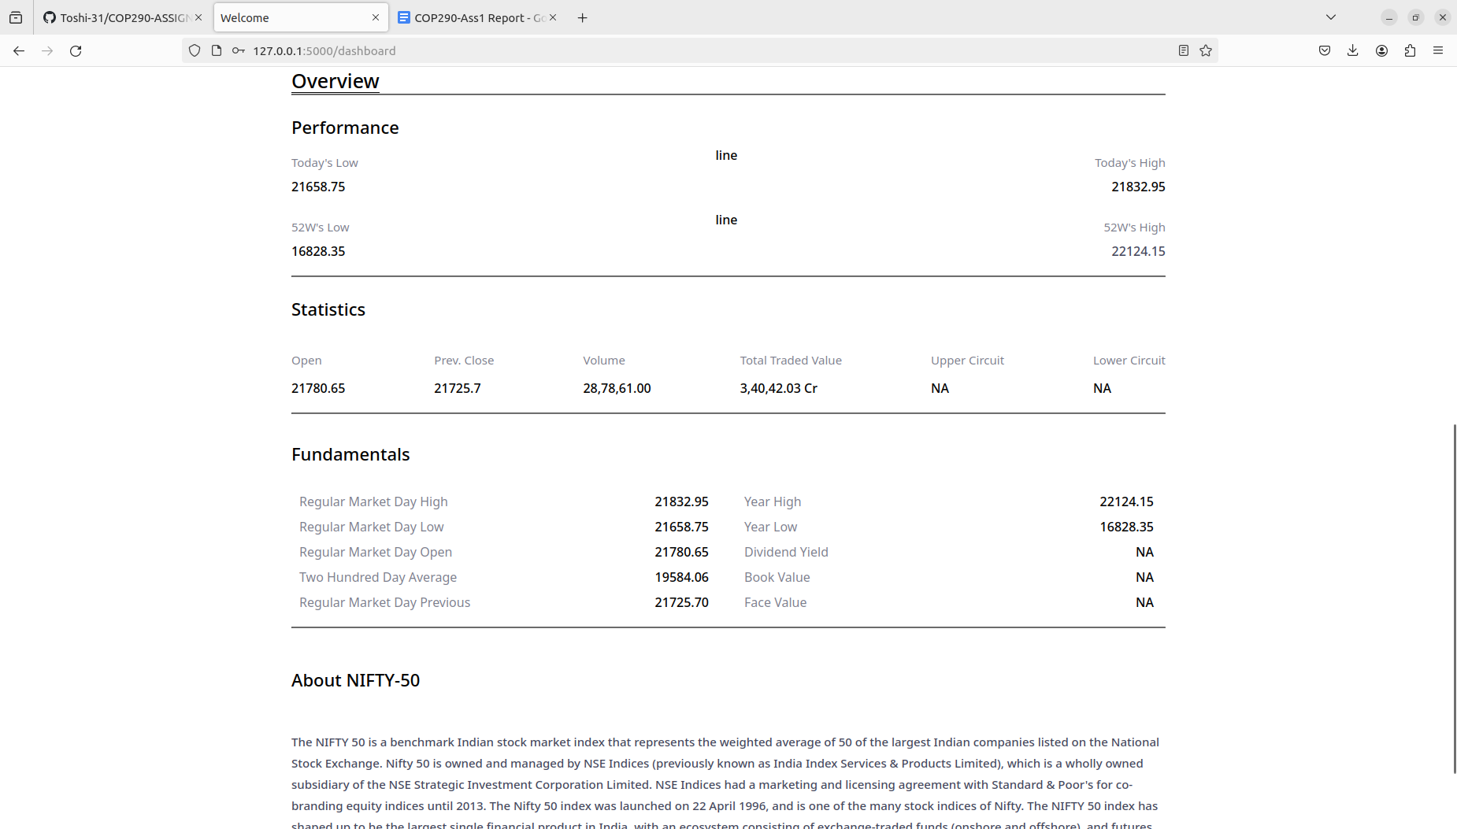

STATISTICS OF ONE STOCK

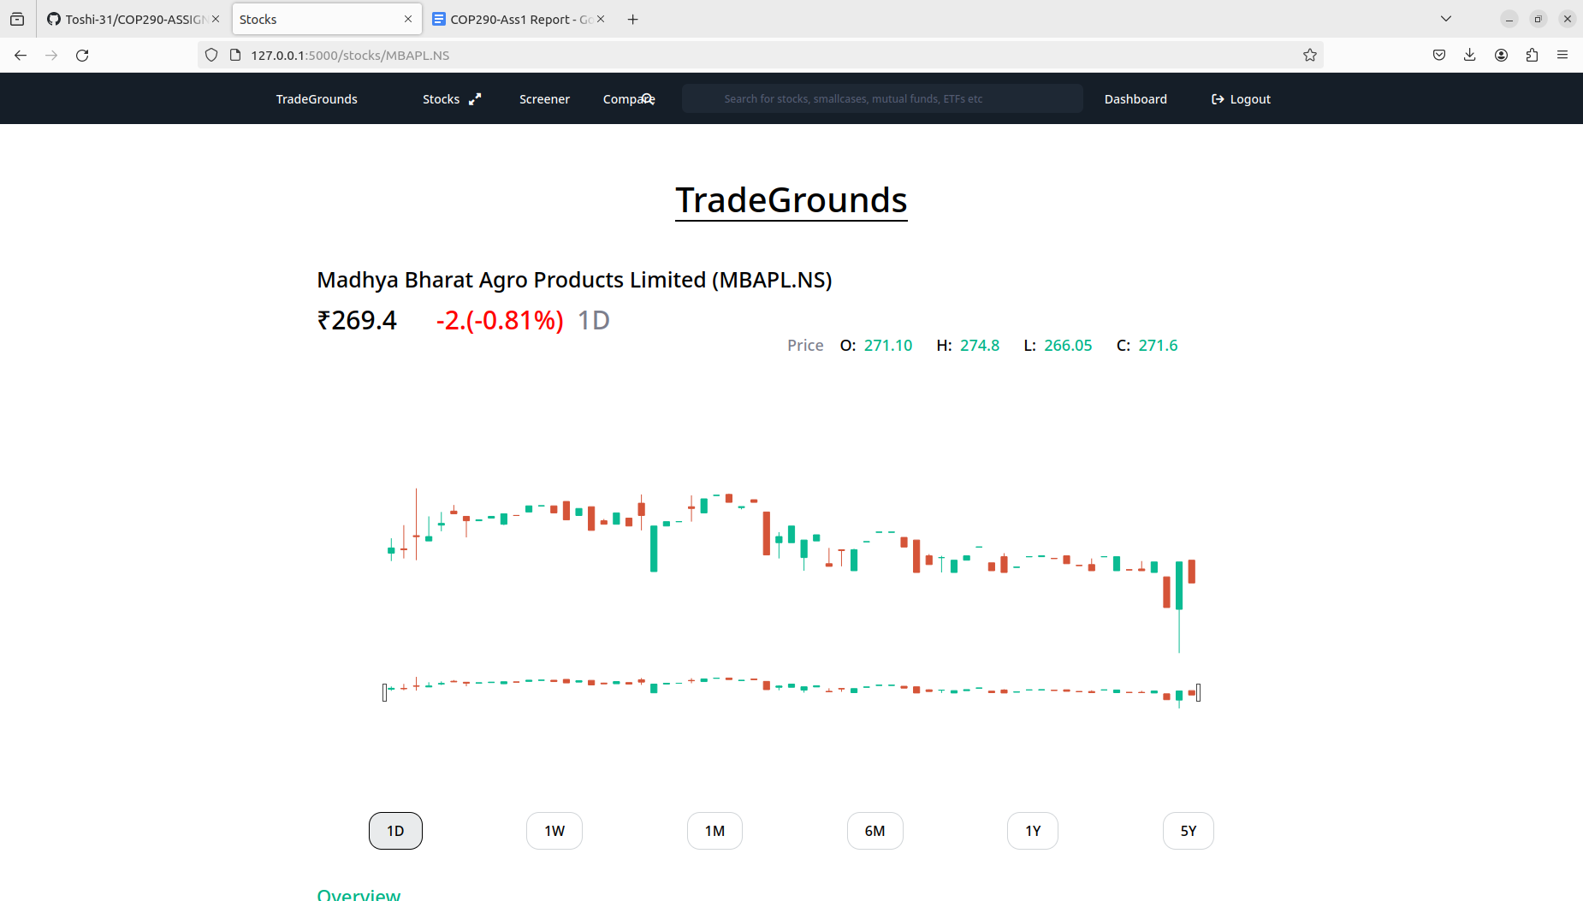

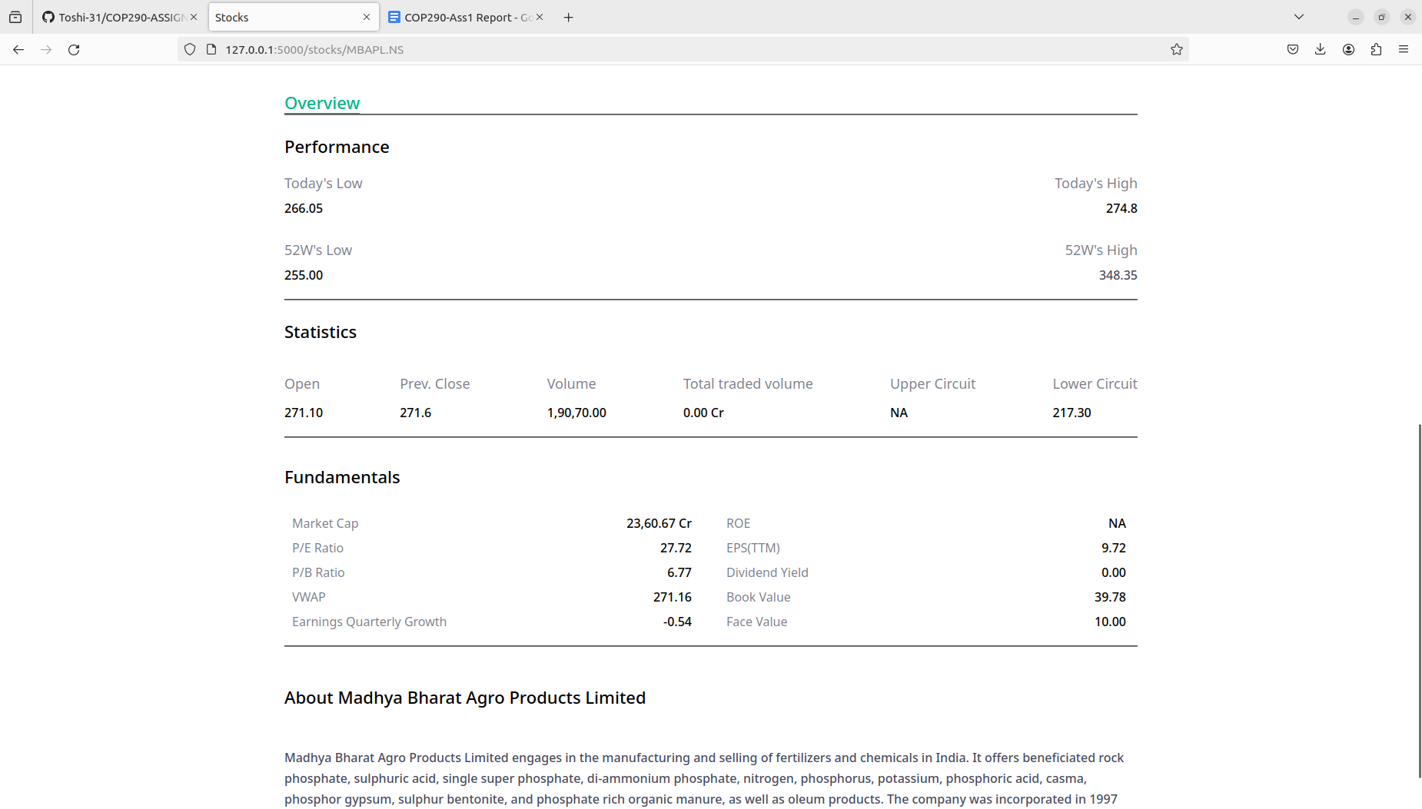

FILTERING STOCKS

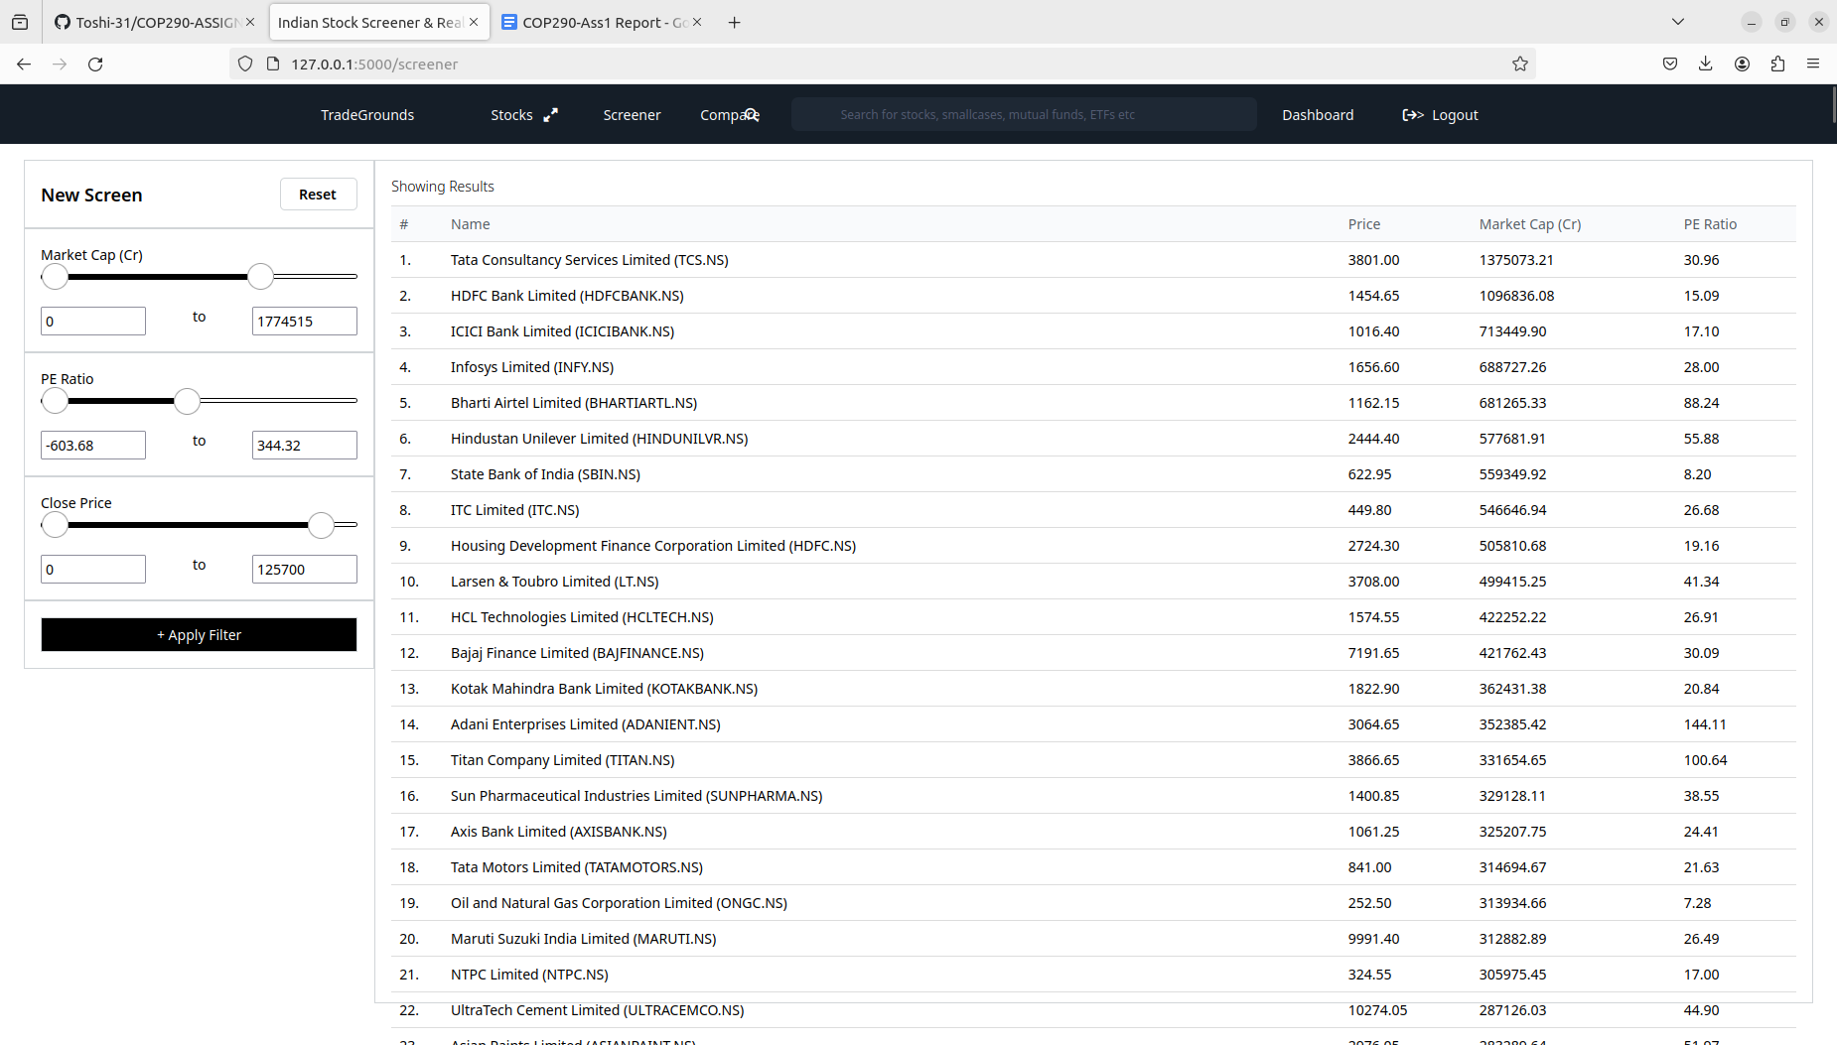

COMPARING TWO STOCKS

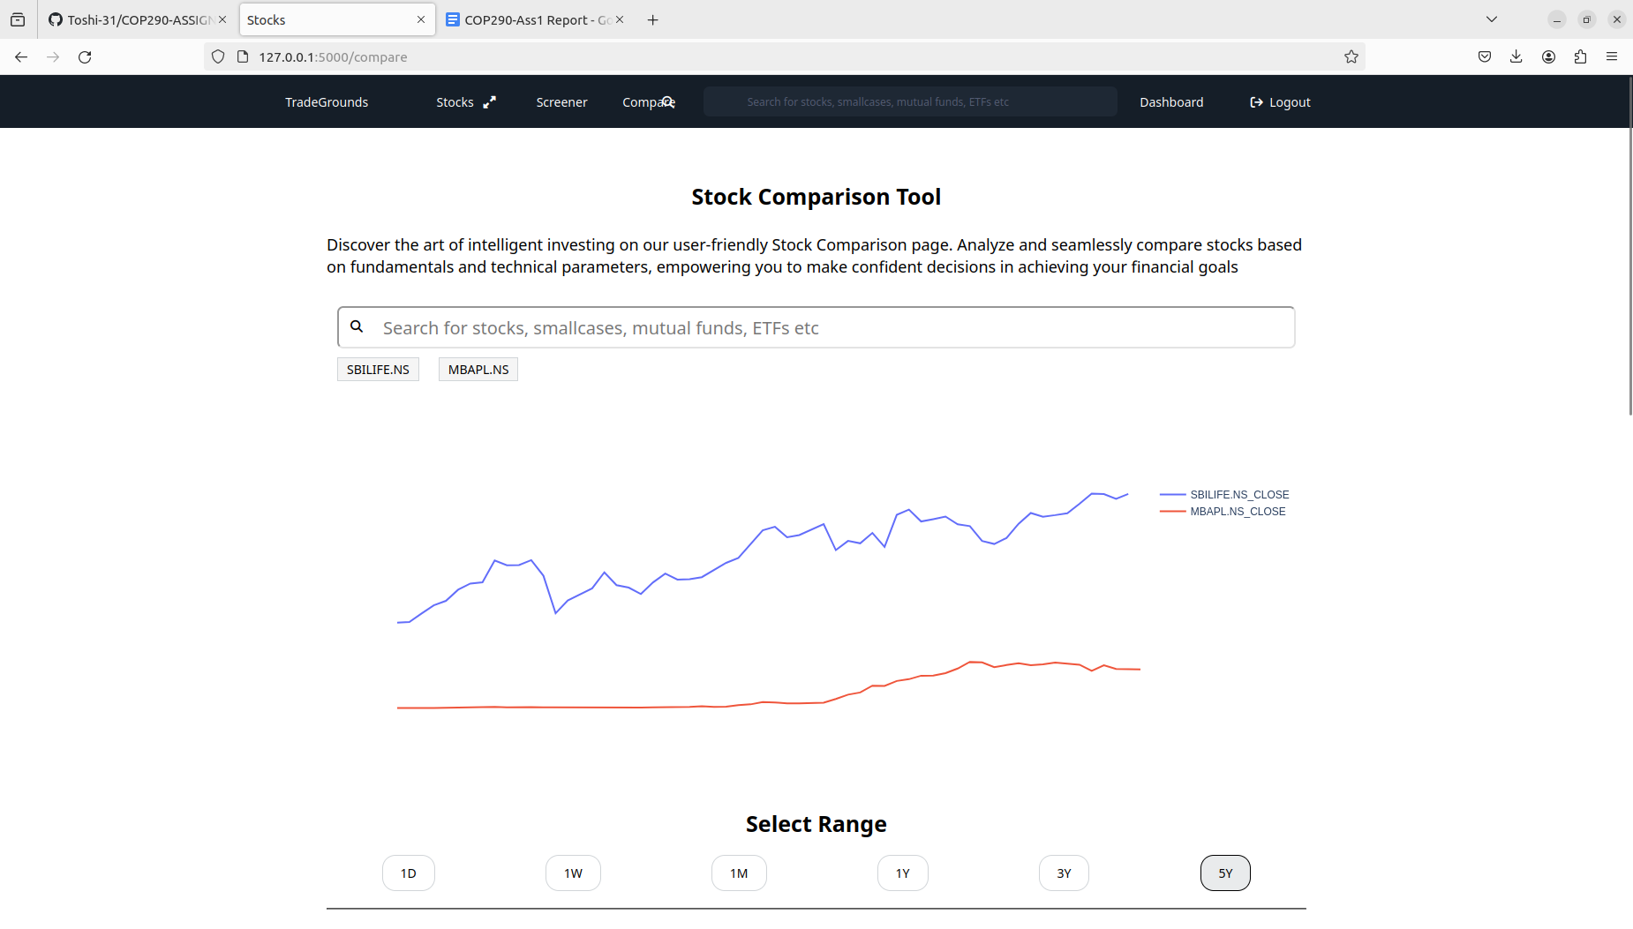

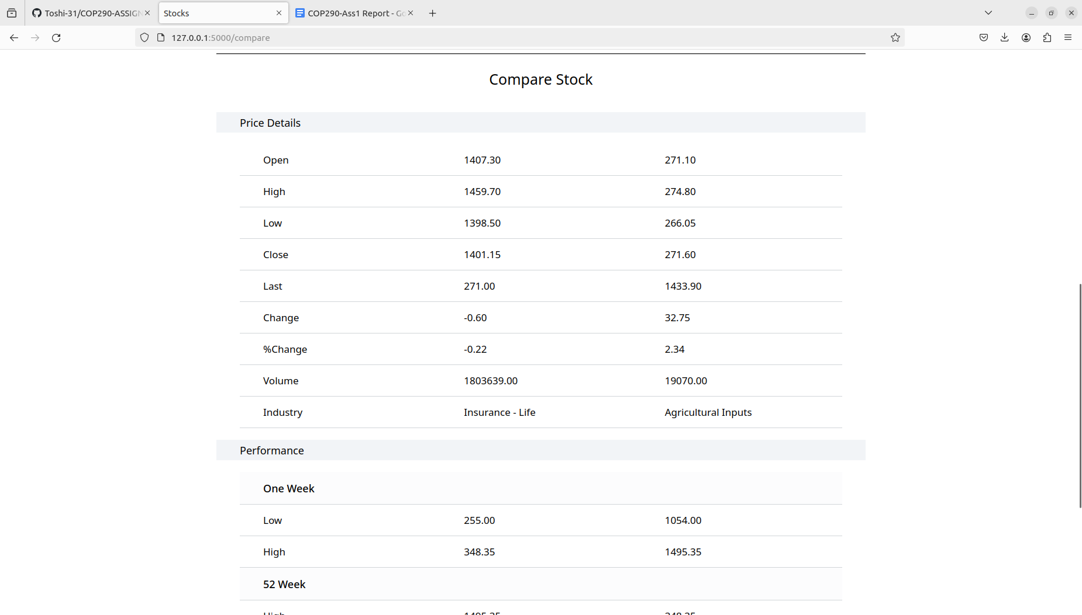

FINAL COMMIT HISTORY

